KPI’S REQUIREMENTS
Total revenue

SELECT SUM(total_price) AS Total_revenue FROM pizza_sales
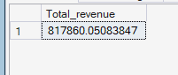

Average order price

SELECT SUM(total_price)/COUNT(DISTINCT order_id) FROM pizza_sales

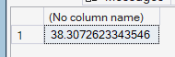

Total pizza sold

SELECT SUM(quantity) AS total_pizza_sold FROM pizza_sales

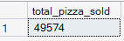

Total orders

SELECT COUNT(DISTINCT order_id) AS total_orders FROM pizza_sales
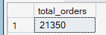

Average pizza per order

SELECT SUM(quantity)/COUNT(DISTINCT order_id) AS AVERAGE_PIZZAS_PER_ORDER FROM pizza_sales

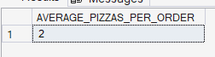
Average pizza per order in decimal
SELECT CAST(SUM(quantity) AS decimal(10,2))/CAST(COUNT(DISTINCT order_id)AS decimal(10,2)) AS AVERAGE_PIZZAS_PER_ORDER FROM pizza_sales

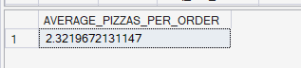

CHARTS REQUIREMENT
DAILY TREND FOR TOTAL ORDERS

SELECT DATENAME(DW,order_date) AS order_day,COUNT(DISTINCT order_id) AS orders FROM pizza_sales
GROUP BY DATENAME(DW,order_date)
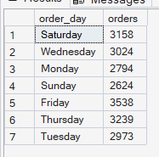
MONTHLY TREND FOR TOTAL ORDERS

SELECT DATENAME(MONTH,order_date) AS months,COUNT(DISTINCT order_id) AS orders FROM pizza_sales
GROUP BY DATENAME(MONTH,order_date)
ORDER BY orders DESC
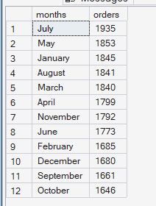

Pizza sales per category in distribution in montht
SELECT pizza_category,SUM(total_price) AS total_sales,SUM(total_price)*100/(SELECT SUM(total_price) FROM pizza_sales WHERE MONTH(order_date)=1) AS PERCENTAGE_PER_CATEGORY FROM pizza_sales
WHERE MONTH(order_date)=1
GROUP BY pizza_category
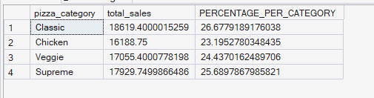

Pizza sales per size in distribution in percentage in month

SELECT pizza_size,
CAST(sum(total_price) AS DECIMAL(10,2)) AS total_sales,
CAST(
SUM(total_price)*100/
(
SELECT SUM(total_price)
FROM pizza_sales
WHERE MONTH(order_date)=1
)
AS DECIMAL(10,2)) AS percentage_per_category
FROM pizza_sales
WHERE MONTH(order_date)=1
GROUP BY pizza_size
ORDER BY percentage_per_category DESC
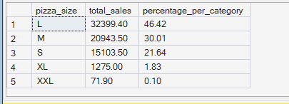

Pizza sales per size distribution per quarter
SELECT pizza_size,
CAST(sum(total_price) AS DECIMAL(10,2)) AS total_sales,
CAST(
SUM(total_price)*100/
(
SELECT SUM(total_price)
FROM pizza_sales
WHERE DATEPART(quarter,order_date)=1
)
AS DECIMAL(10,2)) AS percentage_per_category
FROM pizza_sales
WHERE DATEPART(quarter,order_date)=1
GROUP BY pizza_size
ORDER BY percentage_per_category DESC

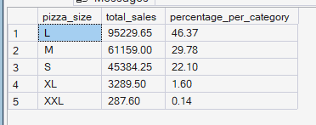
TOP 5 BEST REVENUE PIZZA

SELECT TOP 5 pizza_name,SUM(total_price) AS total_revenue FROM pizza_sales
GROUP BY pizza_name
ORDER BY total_revenue DESC

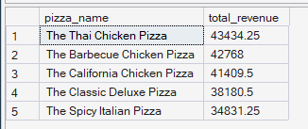

BOTTOM 5 REB=VENUE PIZZA

SELECT TOP 5 pizza_name,SUM(total_price) AS total_revenue FROM pizza_sales
GROUP BY pizza_name
ORDER BY total_revenue

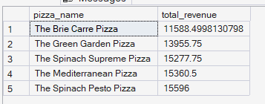

Top 5 pizza by quantity
SELECT TOP 5 pizza_name,SUM(quantity) AS total FROM pizza_sales
GROUP BY pizza_name
ORDER BY total DESC

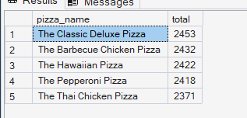

SELECT TOP 5 pizza_name,SUM(quantity) AS total FROM pizza_sales
Bottom 5 pizza by quantity
GROUP BY pizza_name
ORDER BY total
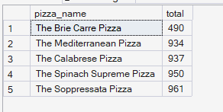
TOP 5 COUNT OF PIZZA BY ORDER_ID

SELECT TOP 5 pizza_name,COUNT(DISTINCT order_id) AS total FROM pizza_sales
GROUP BY pizza_name
ORDER BY total DESC
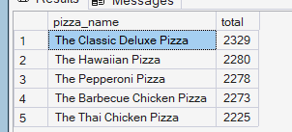

BOTTOM 5 COUNT PIZZA BY ORDER_ID
SELECT TOP 5 pizza_name,COUNT(DISTINCT order_id) AS total FROM pizza_sales
GROUP BY pizza_name
ORDER BY total
